Application form and photo requirements
- Please use ADOBE® Reader 9 to open the file (freeware at http://www.adobe.com/go/EN_US-H-GET-READER )
- Please take note that photocopies of the application form are not acceptable.
- Application form must be printed on Letter paper (8 ½ X 11 in) in following conditions:
- Open the file in Adobe ® Reader
- Use «File» menu, then – «Print»
- 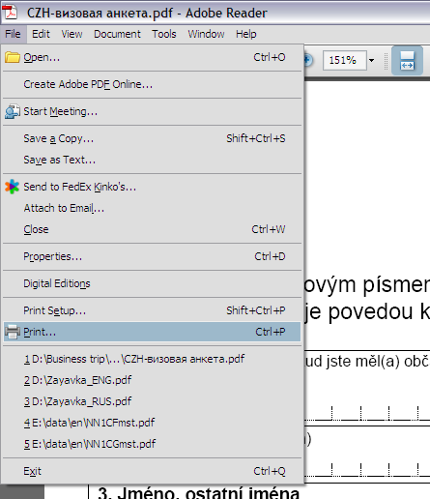
- In new window in «Page Handling» check next options:
  - In «Page Scaling» choose «None»
  - Do not check «Auto-Rotate and Center»
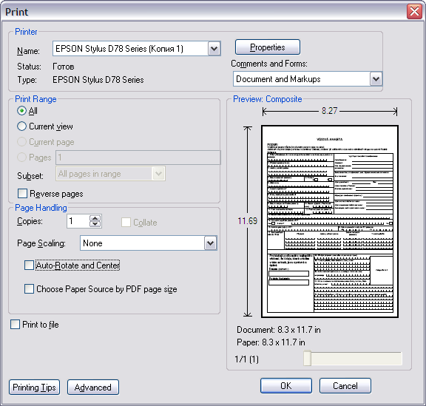

- Application form must meet the following requirements:
- The form must be filled out in capital letters using a black pen or typing machine or computer. Using ink pens is not allowed.
- In each cell of the form you can put ONLY ONE letter or digit.
- 1Writting must be legible
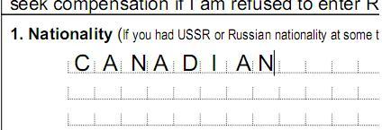
- Questions 1-7 must be answered by all applicants
- Question 8 is to be answered if you know what kind of visa you`re requesting
- Question 12 is to be answered, if you have already visited Russia
- Questions 13-14 must be answered by all applicants
- Question 15 is to be answered if you have medical insurance valid in Russia. You should put policy number and the name of insurance company.
- Question 16 is to be answered if you are travelling with the children included in your passport. A child having own passport must apply for a visa separately.
- Questions 18-21 must be answered by all applicants
- Your photo must meet following requirements:
- The frame size must be 35 mm X 45 mm (1 3/8" X 1 3/4").
- Photo must be made within the last 6 months before the date of application
- The photos must be clear, well defined and taken against a plain white or light-coloured background
- Your face must be square to the camera with a neutral expression, neither frowning nor smiling, and with your mouth closed
- Sunglasses are not acceptable
- The photos must show the full front view of the head, with the face in the middle of the photo, and include the top of the shoulders.
- THE PHOTO MUST BE GLUED ON THE FORM STRICTLY AT RESERVED SPACE.

